

Lab Assignment
Title:
Task 2 & 3
Submitted to :
- Instructor : Ma’am Khaula Qadeer
- Course : Artificial Intelligence (CSC-262)
Submitted by:
- Name : Sannan Ahmad
- Reg # (SP25-BSE-118)
- Section A

Date of Submission:
09 Oct, 20266

TASK 03: User input with a solvability check
SOLUTION:
- Input: the user enters the start state row by row. Input is rejected unless it has exactly 9 values, each of 0–8 used once.
- Solvability: count inversions, meaning pairs of tiles where the earlier one is larger, ignoring the blank. The puzzle is solvable only if the start’s inversion count has the same parity (odd or even) as the goal’s.
- Why parity works: on a 3×3 board, every legal move keeps the inversion parity unchanged. States of different parity can therefore never reach each other.
- If unsolvable: the program says so and stops, without searching.
- If solvable: it runs the same GBFS as Task 2 and prints the same output.
- Limitation: GBFS ignores the cost of the path so far. It is fast, but its solutions are not always the shortest, as with the 24-step solution for 8 1 3 / 4 _ 5 / 7 2 6.
OUTPUT:
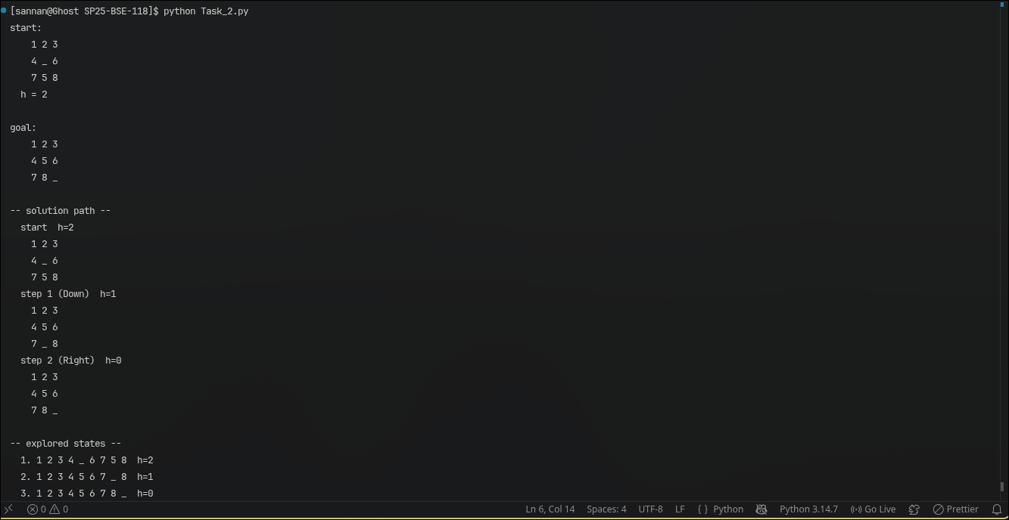

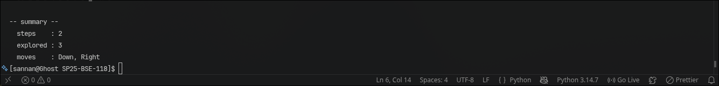
TASK 02: GBFS on a fixed start state
Solution:
- State: a tuple of 9 numbers in row-major order, with 0 as the blank.
- Heuristic: h(n) is the number of misplaced tiles, not counting the blank. The start 1 2 3 / 4 _ 6 / 7 5 8 has h = 2 (tiles 5 and 8).
- Search: a priority queue ordered by h(n) only, with ties broken first-in-first-out. A closed set stops the same state being expanded twice.
- Steps: pop the lowest-h state, stop if it is the goal, otherwise generate its moves (the blank goes up, down, left or right) and push the new states.
- Path: parent links are followed back from the goal to rebuild the sequence of states.
- Output: the path with h for each state, the explored states in order, and the total step count.
- Result: 2 steps (Down, Right), with h going 2 → 1 → 0 and 3 states explored.
OUTPUT:
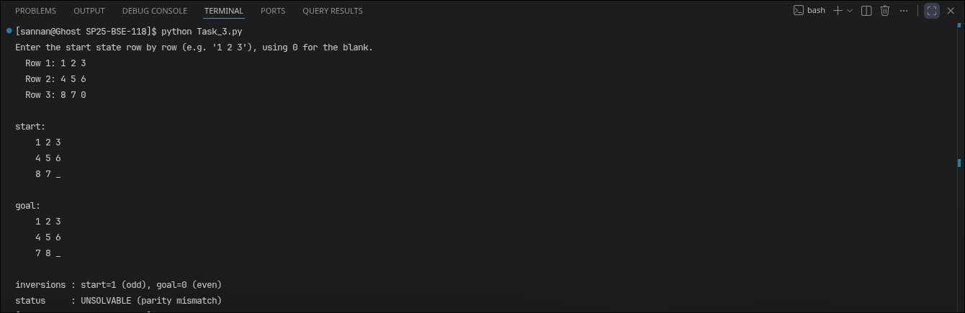

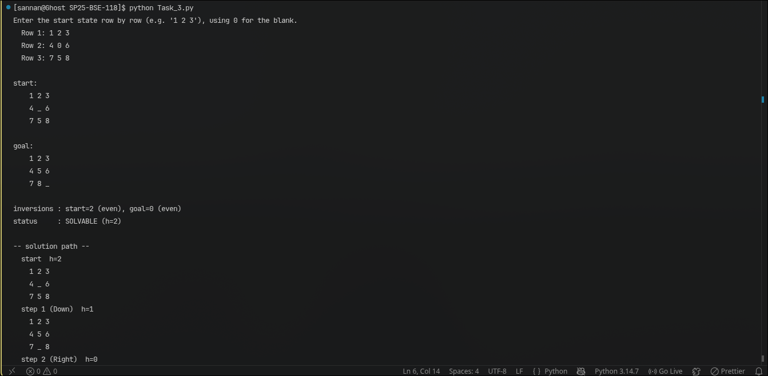
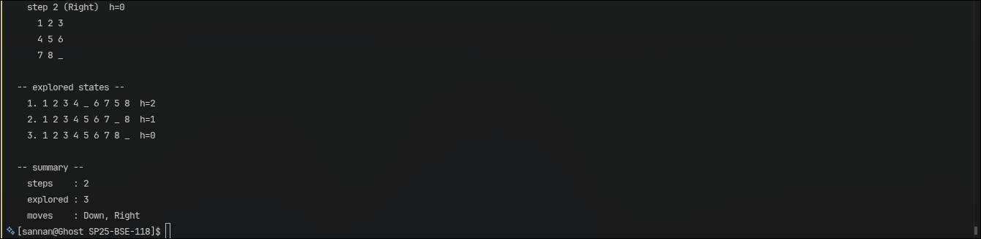
FIN !

